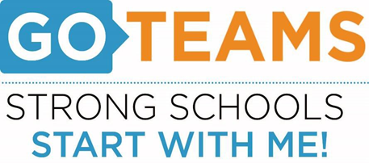

**MEETING NOTICE**

|  |  |  |  |
| --- | --- | --- | --- |
| **School** | **Date** | **Time** | **Location** |
| John Wesley Dobbs | Nov. 30, 2023 | 4:00pm- 6:00pm | [**https://atlantapublicschools-us.zoom.us/j/86844117045?pwd=bWxoZ0FQNktIVndtWXY2Mm4yVEtTdz09**](https://atlantapublicschools-us.zoom.us/j/86844117045?pwd=bWxoZ0FQNktIVndtWXY2Mm4yVEtTdz09)    **Meeting ID: 868 4411 7045**  **Passcode: GoTeam**  **Youtube: Dobbs Elementary**  **@dobbselementaryschool8427** |

**Notice Prepared By:** Sonja Yarbrough **Date Posted: 11/17/23 .**

**Meeting Agenda**

(*agenda may be amended*)

*This meeting will allow for Public Comment*

1. **Call to Order**
2. **Roll Call; Establish Quorum**
3. **Action Items** 
   1. Approval of Agenda
   2. Approval of Previous Minutes
   3. Action Item 1: Vote on Additional Meeting Date
   4. Action Item 2: Fill Community Vacancy
4. **Discussion Items** 
   1. Discussion Item 1: School Strategic Plan
      1. Strategic Plan & Priorities Review
      2. Smart Goals
   2. Discussion Item 2: Data Discussion
      1. Spring 2023 MAP Results
      2. 2023 Ga. Milestone Results

c. Discussion Item 3: Rollins Center Literacy Initiative

1. **Information Items** 
   1. Principal’s Report
      1. Enrollment and Leveling Update
      2. Star Report
      3. Write Score Assessment
   2. CCRPI (only if released by Ga DOE)
2. **Announcements** 
   1. October and November School Event Highlights
3. **Public Comment**
4. **Adjournment**